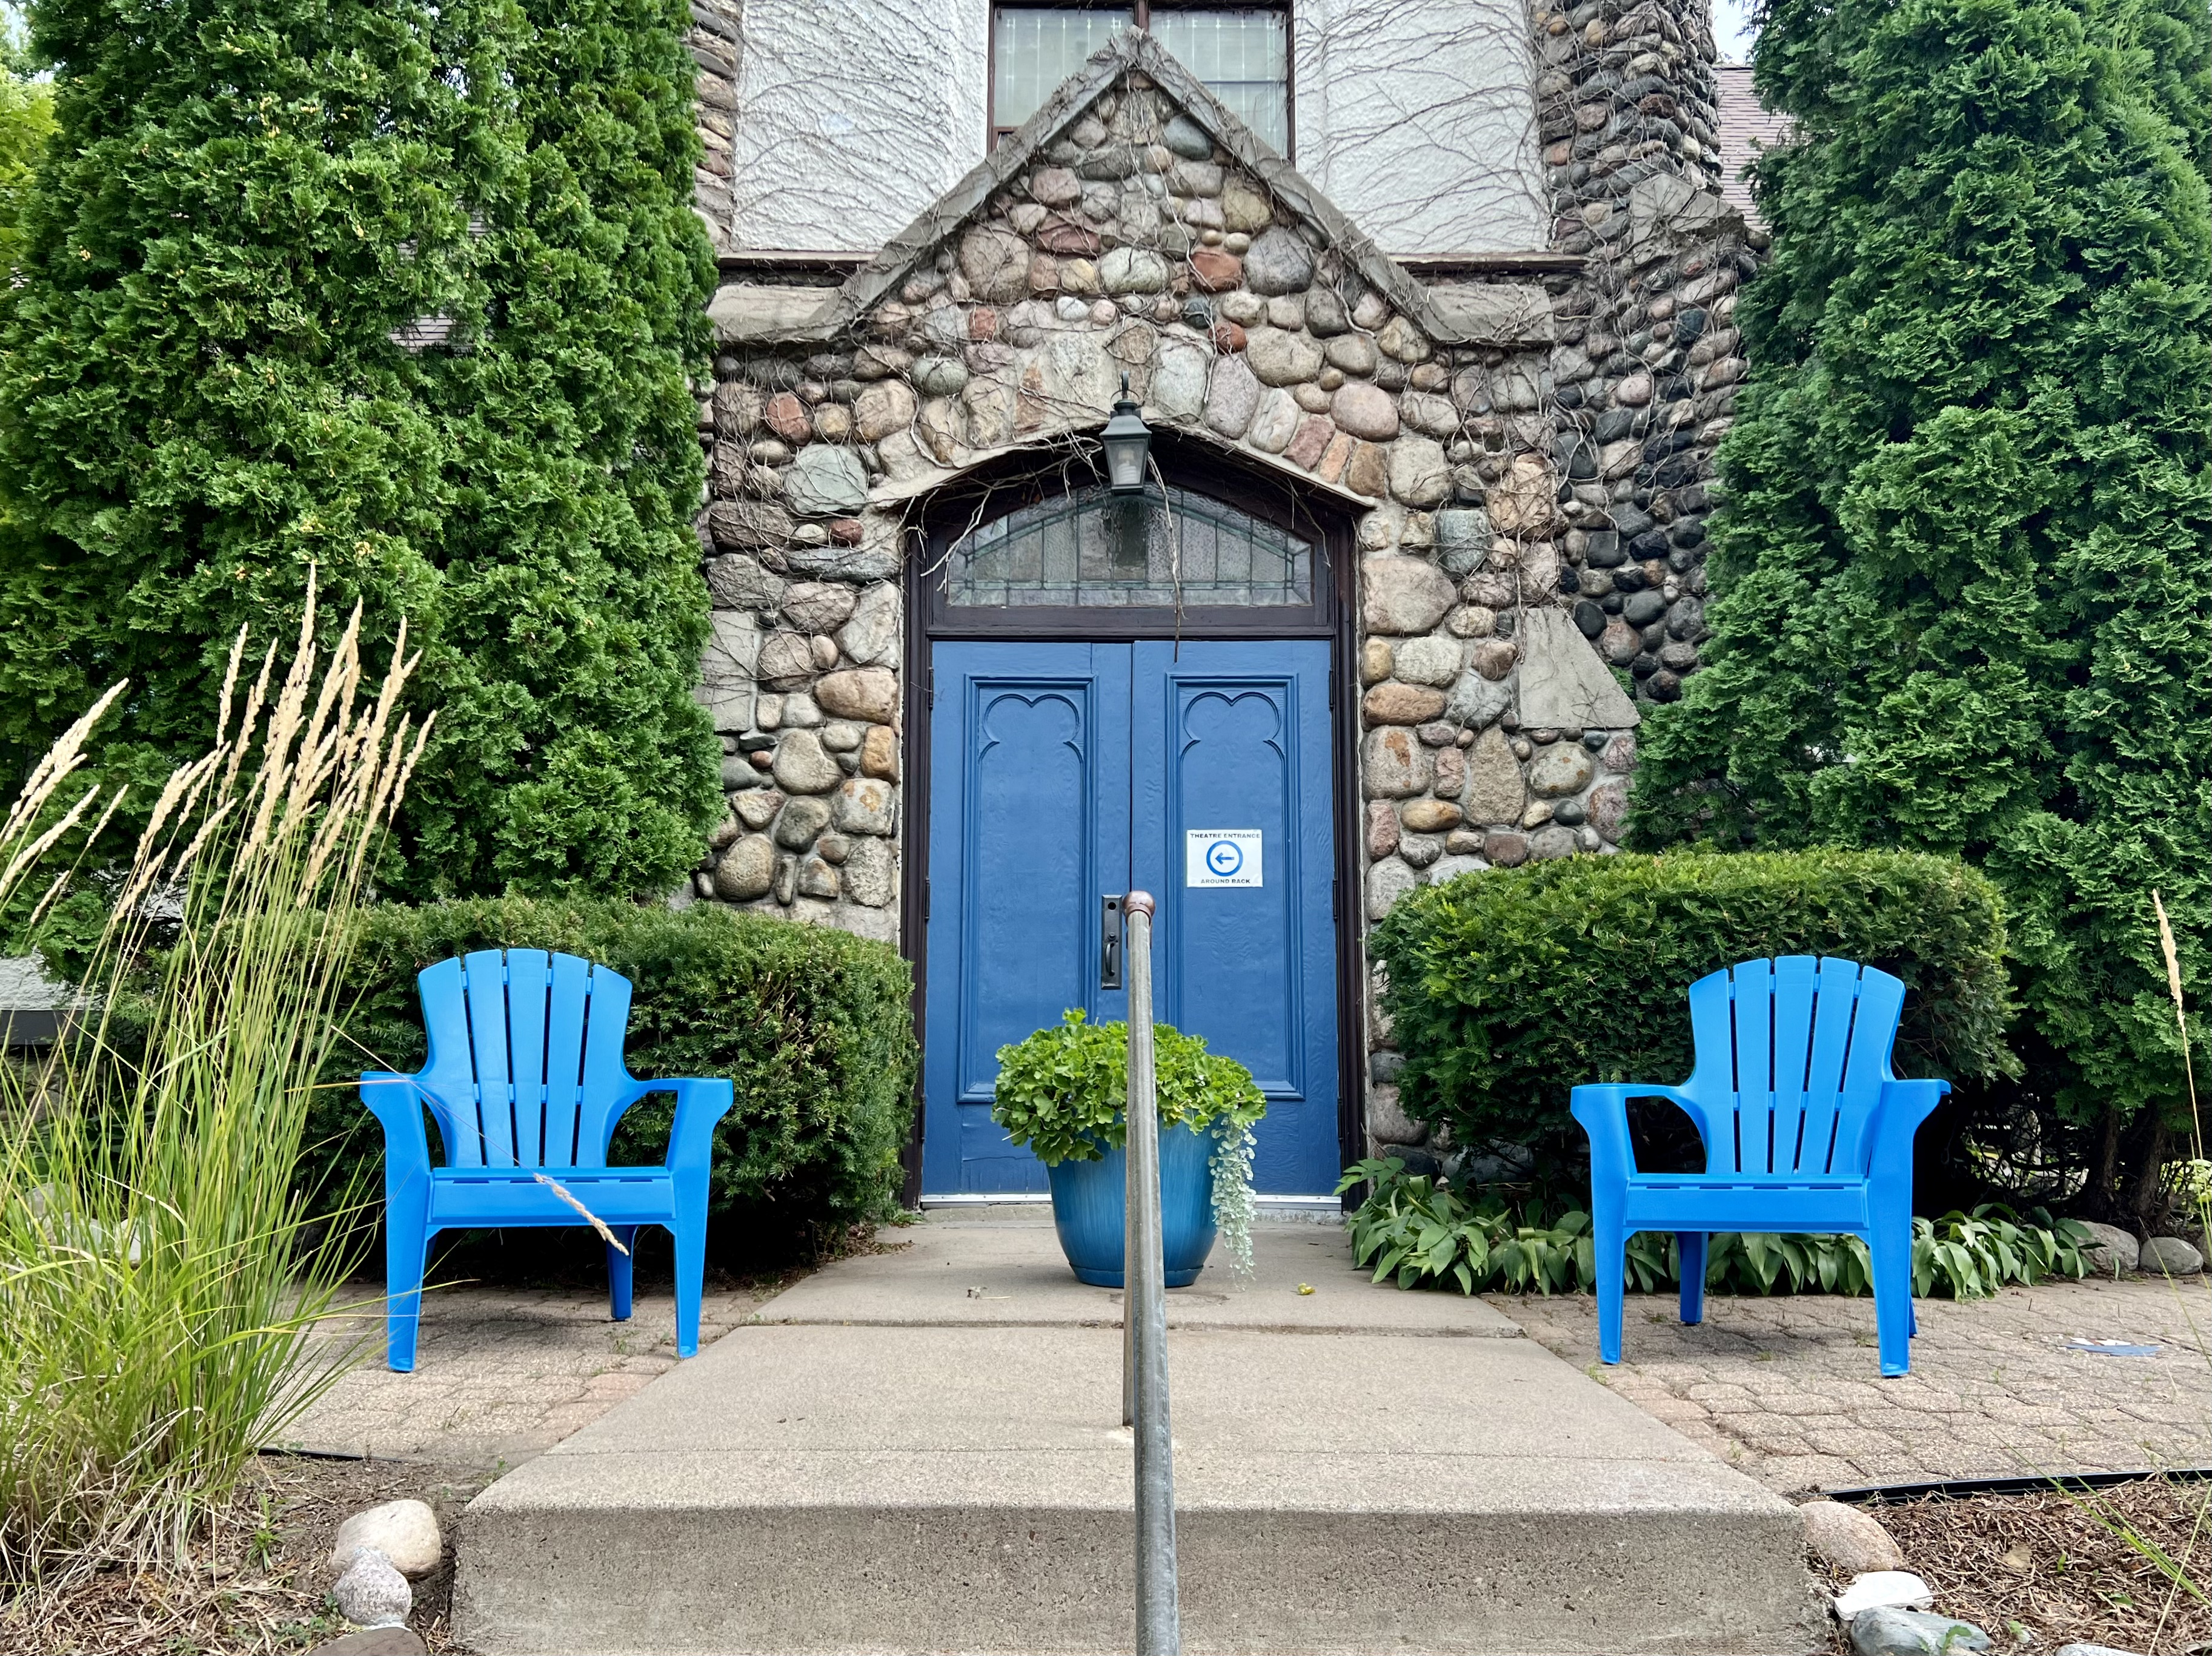


Lorem Ipsum September 13, 2024
Join in on the fun!

Marketing
Content generation, event planning, & community relations etc.

Governance
Policies, procedures, oversight & safety. etc.

Development
Fund raising, sponsor & donor relations, & finance etc.

Facilities
Fixing, mowing, weeding & running errands etc.

Scan for easy ways to help or to join a fun committee.

VOLUNTEERING

Volunteer as a Family!

We invite our families and neighbors to get involved in our committees. You can pass out flyers, organize props, talk to people about why you love BWTC and more.

Oftentimes, young people just want to BE at Blue Water. Lean into that! Spend quality time contributing together to an organization we all love!

The theatre relies on, and belongs to, us all.

We are its !

BWTC Staff & Board
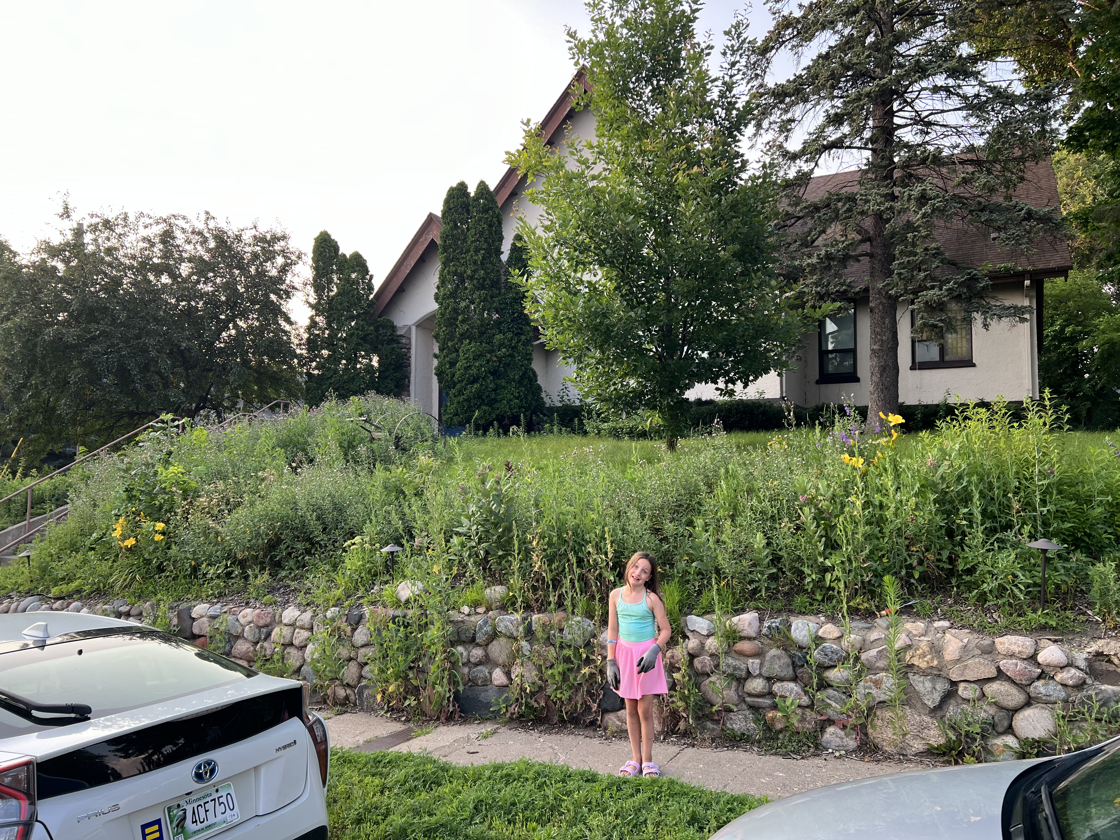

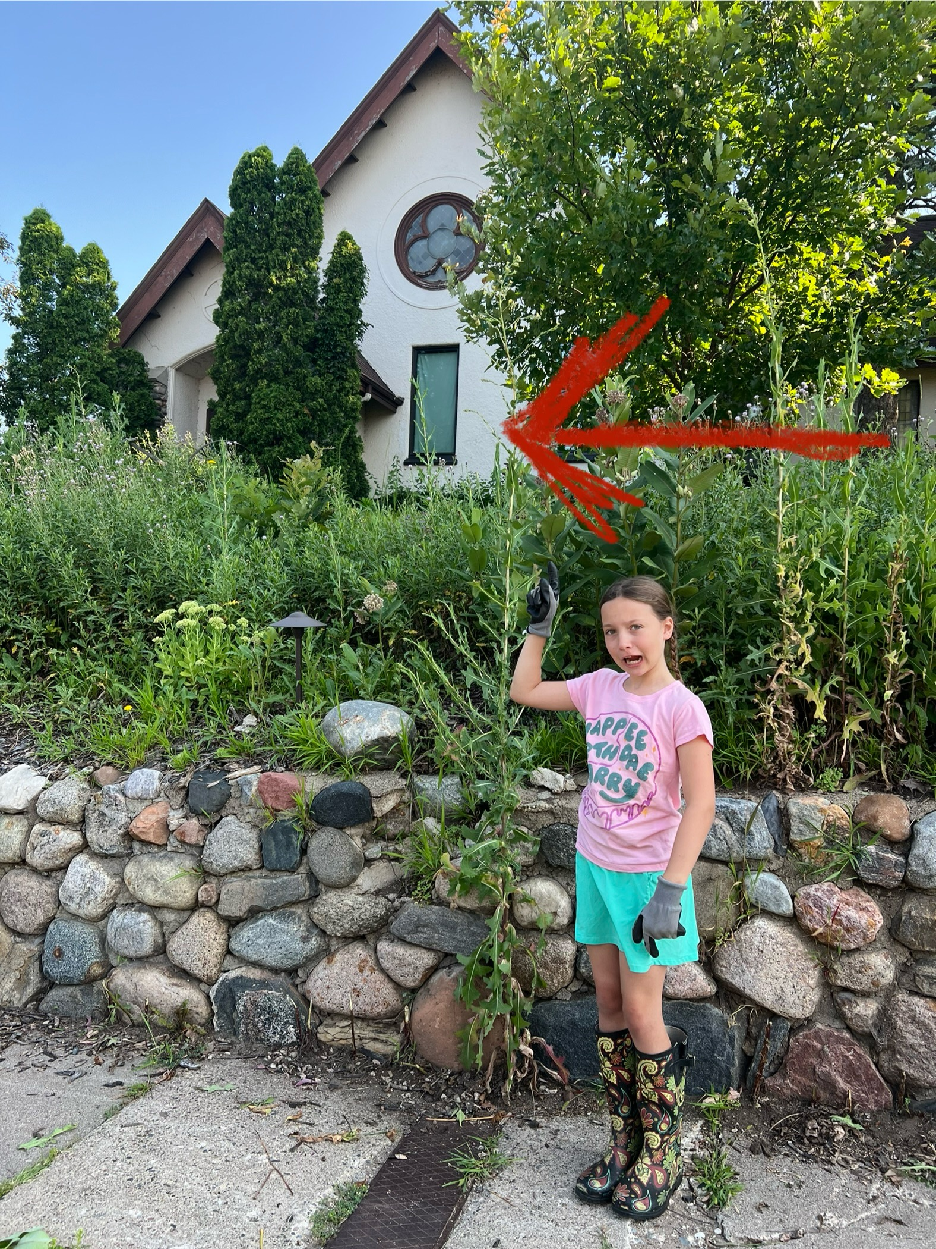


Feature: Girl vs. Thistle
BWTC actor Chaya and her mom spent far more hours than they will admit weeding thistle at Blue Water this summer. They even went on to trim hedges and tree branches.
“The best for me was that Chaya was asking ME to go to the theatre and weed! She loved the time she spent with me and she loved showing Lela how much we had accomplished. She is really proud of her hard work out there. It’s awesome to see that pride and effort in your child.”
- Janessa

Communication Channels

We are creating more channels to communicate beyond BAND…
Historically, we have communicated primarily through the BAND app. This engages youth and parents but leaves out other families members or community members who may want to contribute but are not part of BAND. We are going to use a new Facebook group to engage friends and fans, as well as a new email address to streamline & improve volunteer communication.

Volunteer Committees

We are offering ways to contribute based on areas of interest….
We are compartmentalizing volunteering into committees, based on areas of interest.
This means, volunteers won’t get every request for help, only those that fall under their committee(s) of interest. If you prefer not to talk to people and like outdoor work, facilities is a great match etc.
Why get involved?

Community theater relies HEAVILY on volunteers…
It takes MANY hands to serve a community theatre’s many needs. A lot of that giving can go unrealized. We hope to make the experience more fun through recognition through news posts, committee t-shirts, and an annual volunteer party - by invitation only! So, join a committee and pitch in so you don’t miss the fun!

